**Data Analyst Assignment**

**Name:- Abir Ghosh**

**Email:-[abirghosh033@gmail.com](mailto:abirghosh033@gmail.com)**

**Contact No:- 9748248459**

**Github:-** **https://github.com/AGTech27/Browsing-Behavior-Analysis-Report.git**

**Browsing Behavior Analysis Report**

**1. Introduction**

**Project Overview**

This report dives deep into user browsing behavior, analyzing web history logs to uncover patterns, engagement trends, and meaningful insights using Power BI and Python. The goal? To understand how users navigate the web and leverage that knowledge for better digital experiences.

**Business Context**

User behavior online is a goldmine of insights. By analyzing browsing history, we can identify peak activity times, user preferences, and common navigation paths. This helps businesses enhance user experiences, optimize content, and refine marketing strategies with data-driven decisions.

**2. Data Cleaning & Preprocessing**

**Understanding the Dataset**

The dataset consists of web history logs with key attributes like:

* **DeviceID:** Unique user session identifier.
* **URL:** The website accessed.
* **Eventtimeutc:** Timestamp of the visit (UTC format).
* **Transition**: Navigation type (e.g., link click, reload, direct entry, etc.).
* **Title:** Page title of the visited site.
* **VisitID:** Unique session identifier.
* **ReferringVisitID:** Previous session that led to the visit.

**Data Preprocessing in Power BI**

**Step 1: Cleaning the Data**

* Removed redundant metadata and extra headers.
* Dropped unnecessary columns to keep only relevant data.

**Step 2: Convert Data Types**

* Converted eventtimeutc into a structured **Date/Time** format.
* Changed visitID and referringVisitID into **Whole Numbers** for easier analysis.

**Step 3: Extract New Features**

* Extracted **Visit Date** and **Visit Hour** from eventtimeutc for time-based insights.

**3. Exploratory Data Analysis & Visualizations**

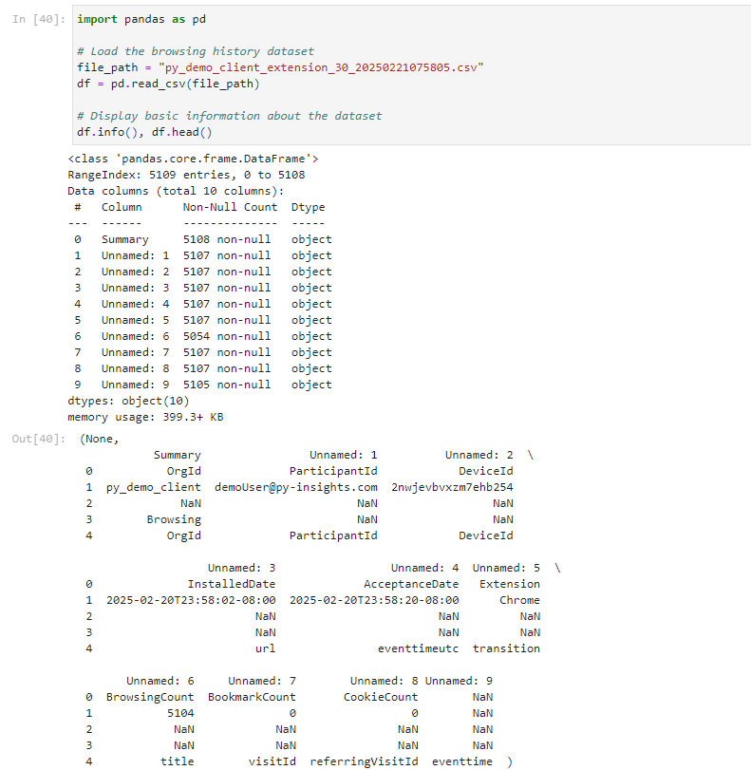

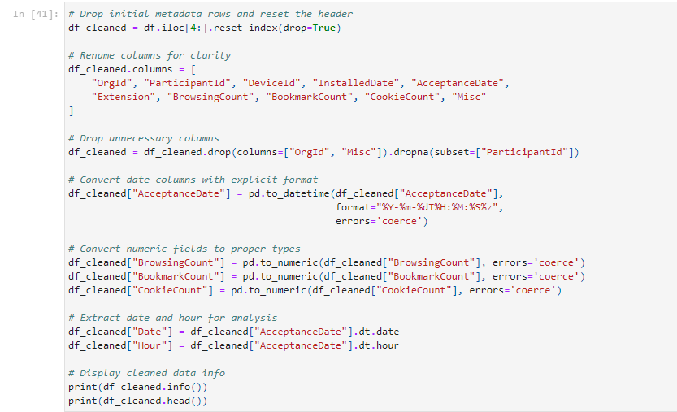

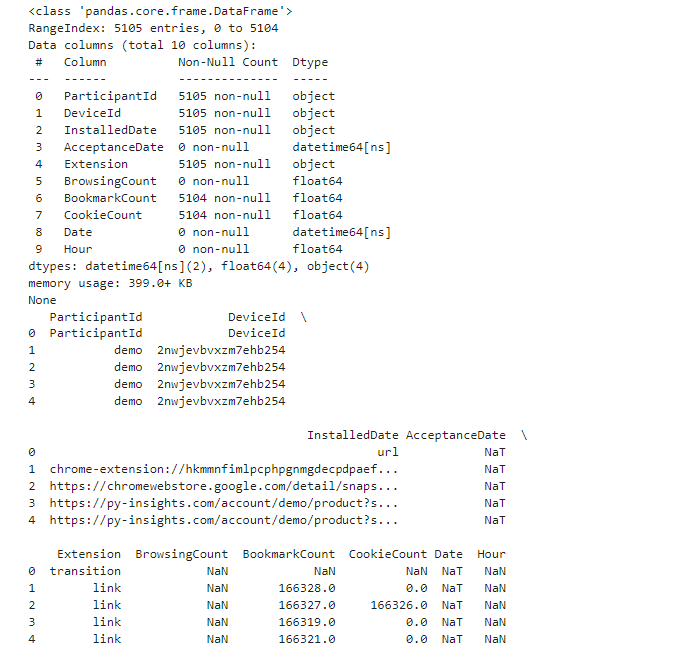

**Browsing Trends by Hour**

* **Goal:** Identify peak user activity hours to determine when users are most engaged online. Understanding this helps businesses schedule promotions, content releases, and marketing strategies effectively.
* **Visualization:** Clustered Column Chart, which visually represents usage spikes across different hours of the day.
* 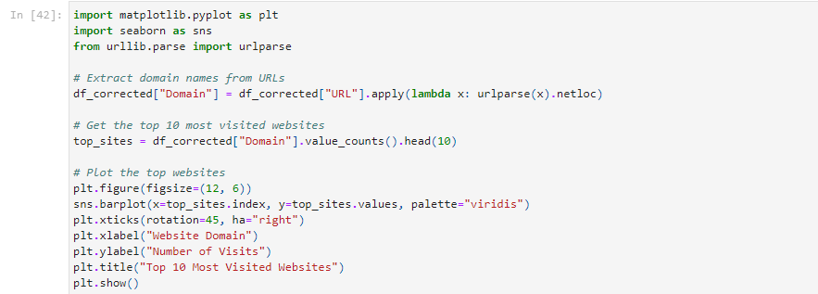**Key Takeaway:** Businesses can use this data to optimize digital engagement, such as posting social media content or running targeted ads during peak hours.

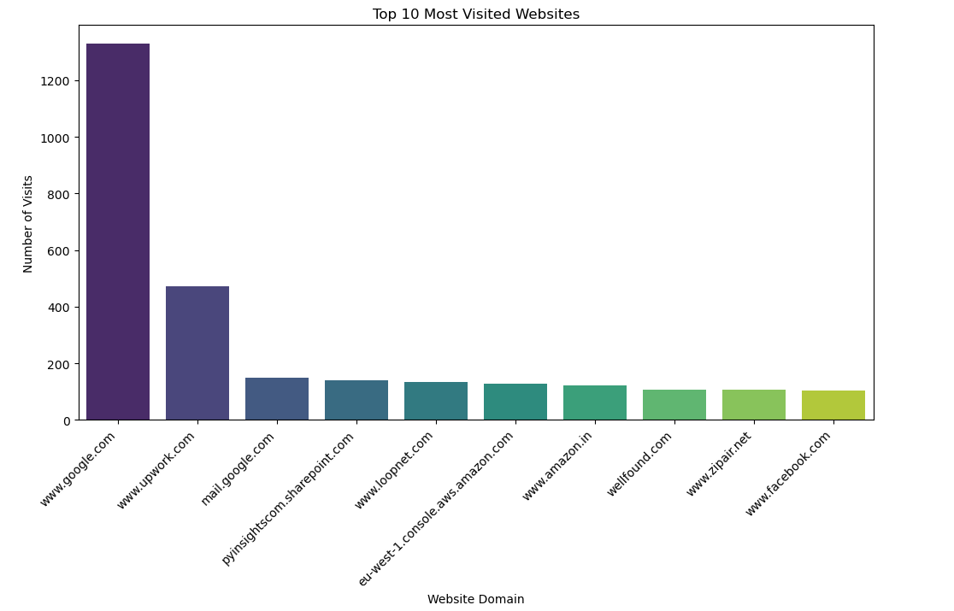

**Daily Browsing Patterns**

* **Goal:** Analyze user activity variations across different days to detect browsing habits and weekly trends.
* **Visualization:** Line Chart, offering a clear trend analysis over time.
* **Key Takeaway:** This insight is valuable for campaign planning, ensuring that businesses reach their audience on the most active days.

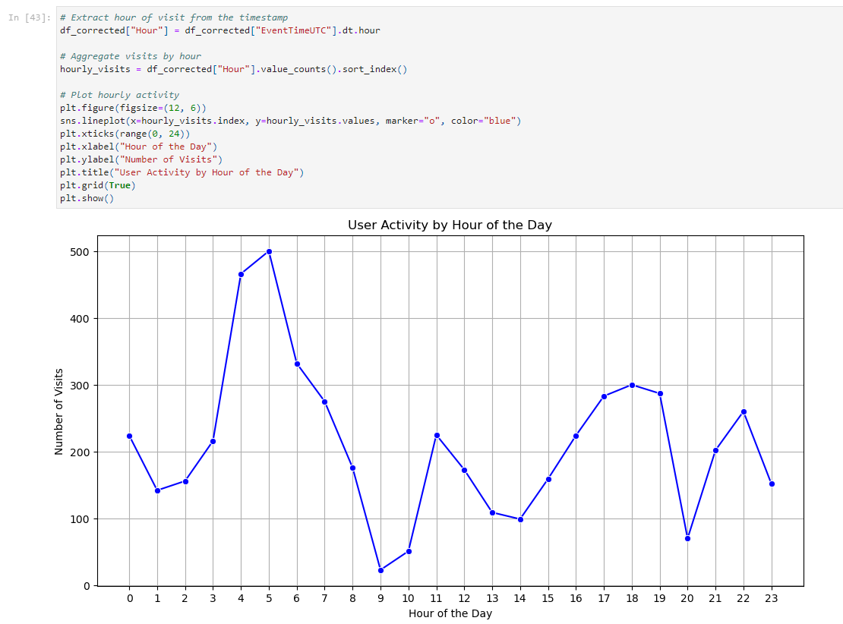

**Most Visited Websites**

* **Goal:** Identify which websites users frequent the most, helping businesses understand user interests.
* **Visualization:** Bar Chart displaying the Top 10 most visited websites.
* 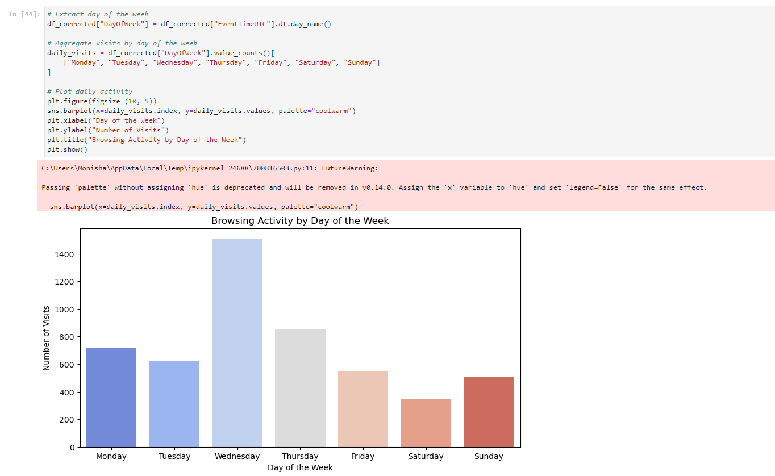**Key Takeaway:** Companies can use this information for targeted advertising, content partnerships, and trend analysis in user preferences.

**Interaction Type Distribution**

* **Goal**: Understand how users navigate different websites—whether they click on internal links, reload pages, or manually type URLs.
* **Visualization:** Stacked Bar Chart, categorizing various navigation methods.
* 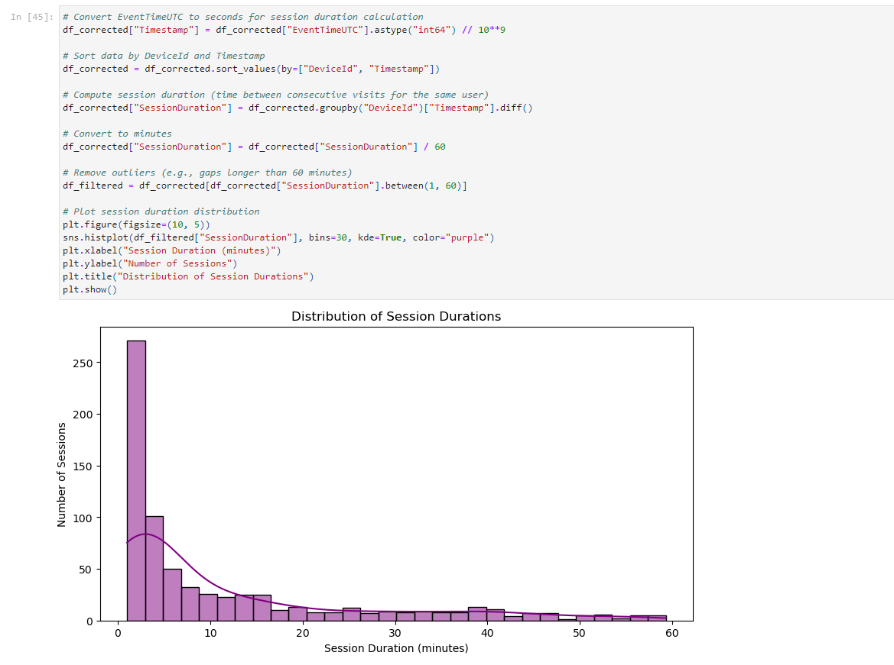**Key Takeaway:** This information helps optimize website UI/UX by focusing on elements that keep users engaged and reducing friction in navigation.

**Top 10 Websites by Average Session Duration**

* **Goal:** Determine where users spend the most time to understand engagement levels.
* **Visualization:** Stacked Column Chart to compare session durations across top websites.
* **Key Takeaway:**
  + **Amazon** and major e-commerce platforms lead in user engagement due to extensive browsing time.
  + **News and service-based websites** retain users for longer durations as they consume content.
  + **Niche content platforms** attract users seeking specific, in-depth information.
  + 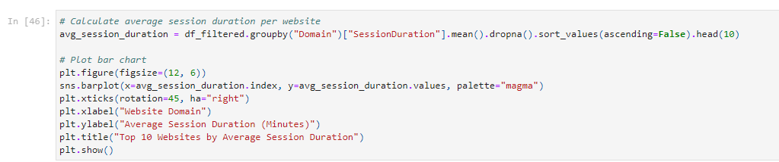**Optimizing UI/UX** for these high-retention websites can further enhance user experience and engagement.

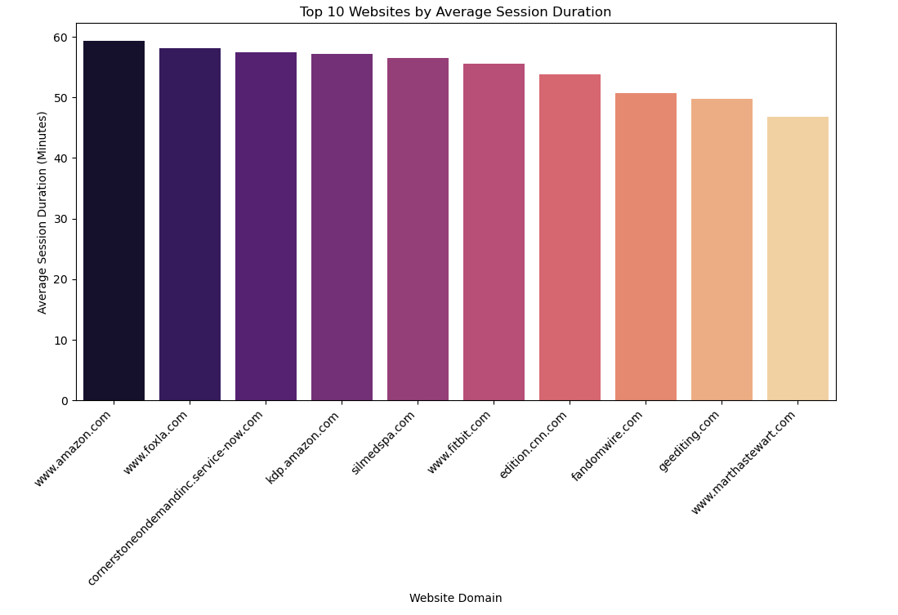

**Top 10 Most Revisited Websites**

* **Goal:** Track how users return to certain websites repeatedly and identify the most frequently revisited domains.
* **Visualization:** Tree Map, showcasing the most revisited websites based on repeat visit counts.
* 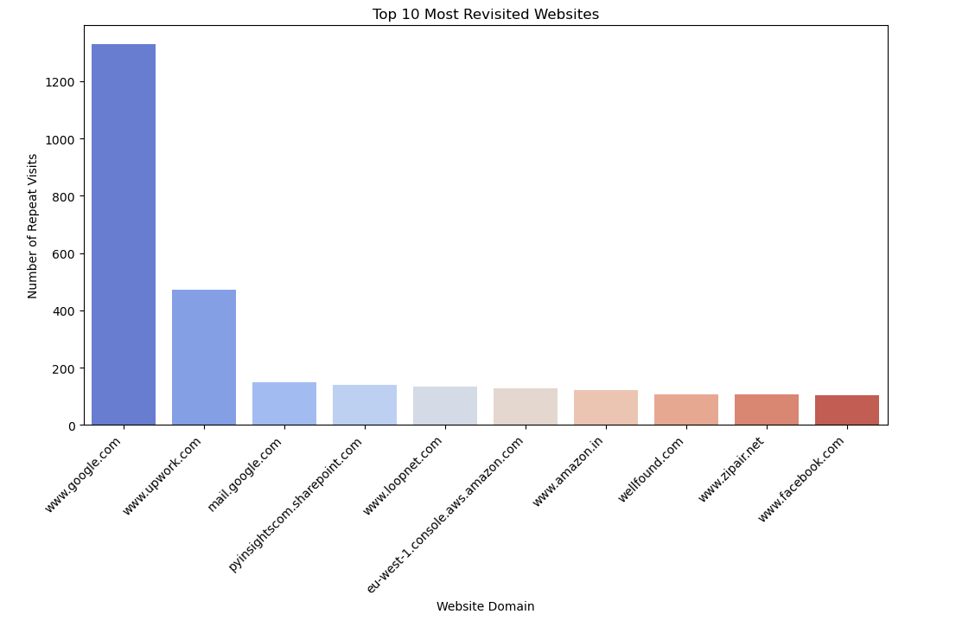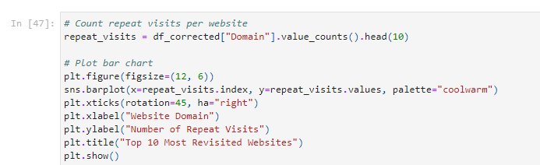**Key Takeaway:** Businesses can use this data to improve content linking strategies, retain returning visitors, and enhance website traffic flow by strategically placing recommended links.

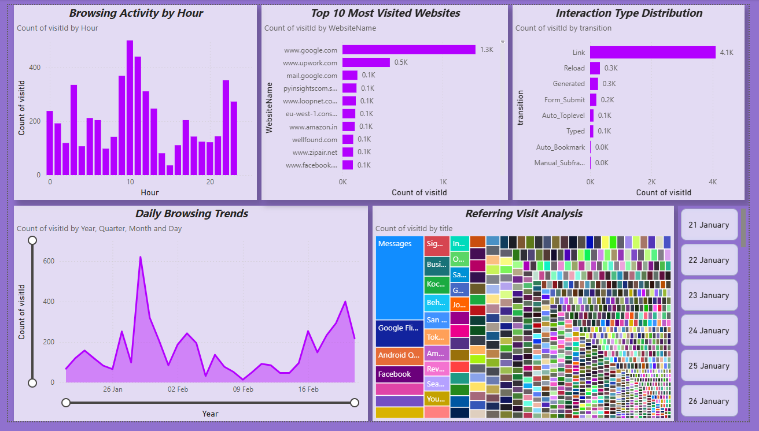**Power BI Dashboard**

**Insights from Power BI Dashboard**

• **Users Have a Preferred "Prime Time" for Browsing**

* The data shows that users are most active during specific hours, likely in the evenings when they have free time. This suggests businesses should time their content releases, social media posts, and ads around these peak hours for maximum engagement.

• **People Revisit the Same Websites Regularly**

* There’s a strong pattern of users revisiting certain sites repeatedly. This could mean they trust these sources, find value in the content, or are making repeated purchase decisions. Companies can leverage this by offering loyalty programs or retargeting ads to keep users engaged.

• **Navigation Habits Show Users Prefer Clicks Over Manual Typing**

* A large percentage of users access websites through internal links rather than typing the URL. This highlights the importance of **intuitive website design and easy navigation**—businesses should ensure key pages are easily accessible through clear CTAs and internal linking strategies.

• **Session Durations Reveal Engagement Levels**

* Some websites have significantly higher session durations, meaning users are deeply engaged. These could be e-commerce sites where users browse multiple products, news portals where they read articles, or educational platforms. Businesses should focus on keeping users engaged with interactive content, recommendations, and personalized experiences.

• **Not All Visits Lead to Immediate Actions**

* Just because a user visits a website doesn’t mean they take action right away. Many return later, possibly after research or comparison shopping. Marketers should use retargeting ads and follow-up emails to capture these users at the right moment.

• **Opportunities for Better User Retention**

* Websites that don’t see repeat visits might need better content strategies. Improving engagement through blog articles, newsletters, or push notifications can help turn one-time visitors into loyal users.

• **Marketing Should Align With Browsing Trends**

* Instead of blindly scheduling posts or campaigns, businesses can **align their marketing with user behavior trends**—posting at peak hours, tailoring content to frequently visited sites, and optimizing for platforms where users spend the most time.

## **4. Key Insights & Strategic Recommendations**

**Key Findings**

* **Peak Browsing Hours:** Users are most active during specific time windows—ideal for engagement strategies.
* **Frequent Website Visits:** Users consistently visit certain sites, revealing strong preferences.
* **User Navigation Trends:** Most users rely on internal links rather than typing URLs manually.
* **Browsing Journeys:** Revisit data helps track user movement across the web.

**Recommendations**

* **Personalized Experiences:** Tailor content based on browsing patterns to increase engagement.
* **Enhanced Site Navigation:** Since most users rely on internal links, improving UI/UX can boost retention.
* **Targeted Marketing:** Use browsing trends to schedule ads and promotions for maximum impact.
* **Content Optimization:** Websites with higher session durations can focus on maintaining engaging content, while lower retention sites should enhance their user experience.

**Conclusion**

This analysis sheds light on user browsing behavior, offering insights that help businesses enhance digital strategies. Power BI’s interactive visualizations reveal browsing trends, peak activity times, and user interaction patterns—key elements for informed decision-making.

**Key Takeaways:**

* Users have specific prime times for browsing, making it essential to schedule content strategically.
* People revisit certain websites regularly, which means businesses should focus on retaining loyal users.
* Navigation trends show that users prefer internal links over manually typing URLs, emphasizing the need for a smooth user experience.
* Not all visits lead to immediate actions—remarketing and follow-ups can help capture returning users.